The PG department of Commerce of St, Gregorios college had organized an international seminar on 16th and 17th of December 2019. The theme of the seminar was Women Entrepreneurship Development and Gender Equality. The seminar was inaugurated by Ms. Ambika Pillai renowned entrepreneur and celebrity stylist and Dr. Sumi Alex Head Of Department Of Commerce and convener of this seminar had delivered the welcome address and Dr, Suman Alexander Principal of St.Gregorios College had delivered the presidential address.
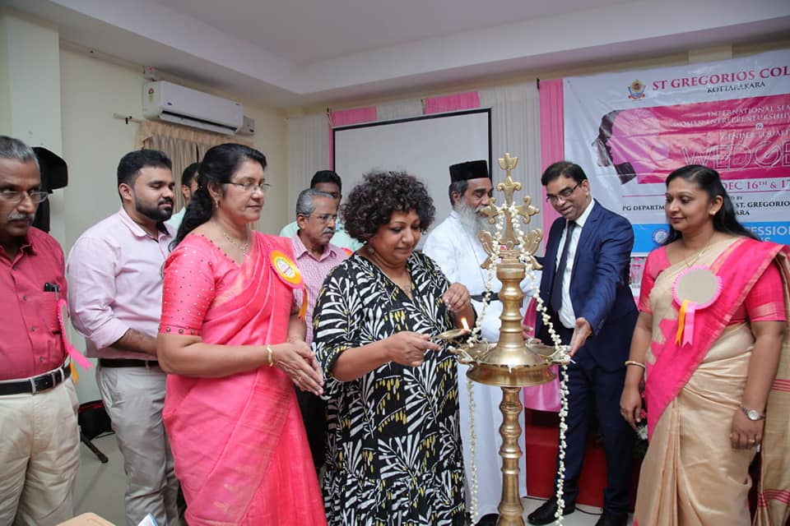

There were four technical sessions in the seminar and about papers were presented by the delegates in different area in the seminar. The technical sessions were handled by Four experts in different areas namely Dr. Ravichandran Krishnamoorthy (Associate Professor, Dept Of Accounting And Finance, School Of Management, Newyork Institute of Technology, Abu Dhabi) Dr. S Kevin (former professor & pro vice chancellor University Of Kerala) Dr P Natarajan(Professor & Coordinator UGC SAP DRS ,Central university Pondicherry),Mrs Chandra Vadhana R( Founder & Chief Mentor,Prayaana) Various delegates presented their research papers on various sub themes of the seminar.

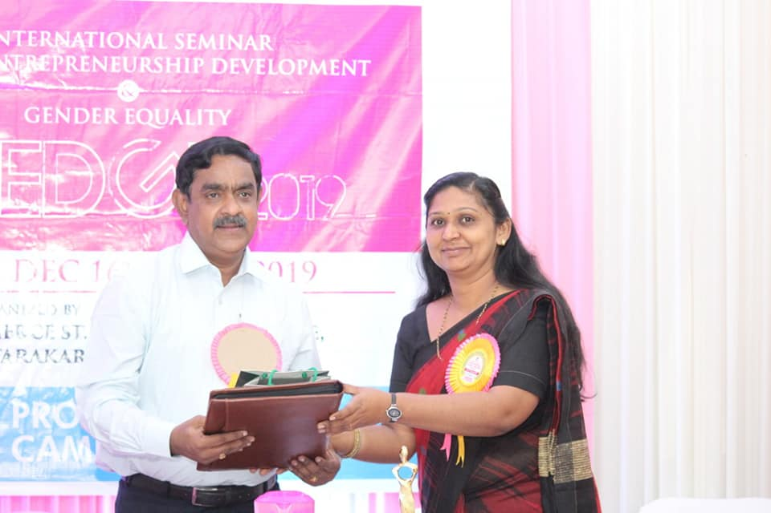

Eminent resource persons shared their views regarding the papers presented in the seminar and gave their valuable inputs. The proceedings of the seminar is released on the very same date by the College Manager, more than 110 articles are included in the proceedings which has an International ISBN. The session was followed by lunch, rich with the traditional recipes to give the delegates a taste of the local flavours.
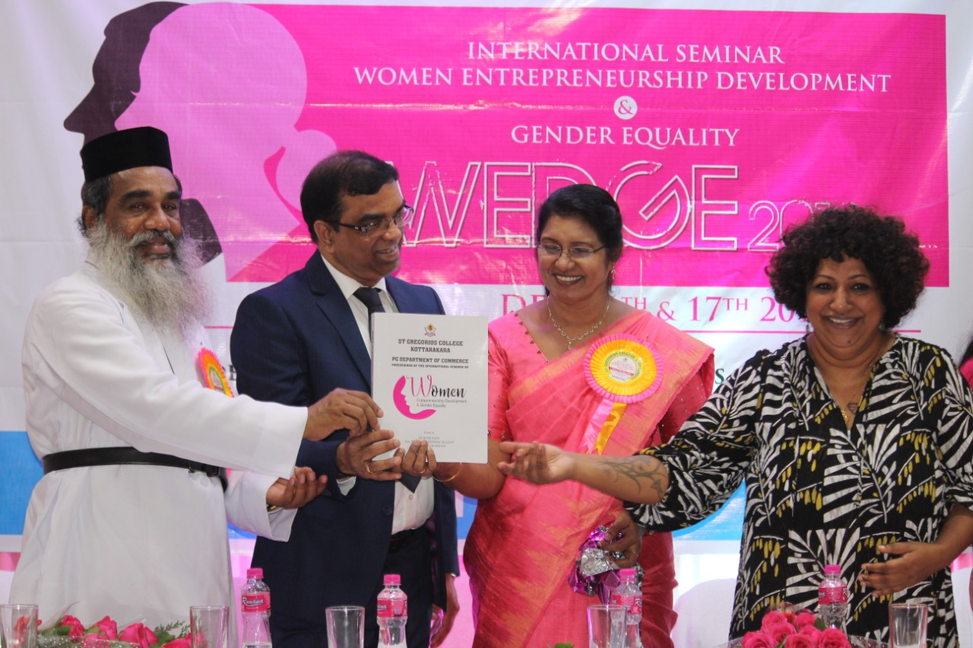

Valedictory Session
In the Valedictory Session Chief guest, SBI Chief Manager, Miss Sheba Thomas shared her views on the success of women entrepreneurs in various fields and a brief outline on the success of women. She emphasized on the point of collaborative performance of women to develop their excellence in various fields. The various schemes and financial assistances provided by the Banks was deliberately addressed by the Chief guest throws a new insight for the perspective entrepreneurs.

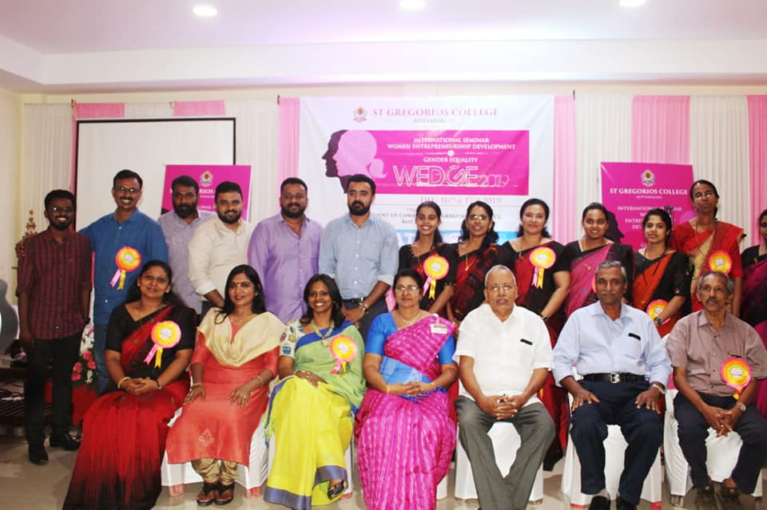

The session was ended by the vote of thanks proposed by Mr.Arun Mohan Assistant Professor ,P G department of Commerce, St. Gregorios College Kottarakara

